From the Minister of State
Huw Merriman MP

Great Minster House
33 Horseferry Road
London
SW1P 4DR

Tel: 0300 330 3000
E-Mail: huw.merriman@dft.gov.uk

Web site: www.gov.uk/dft

31 March 2023
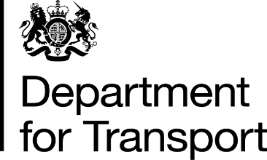

Alberto Costa MP
Dr Luke Evans MP
House of Commons
London
SW1A 0AA

Dear Alberto and Luke,

I am writing following our meeting on 1st February 2023 regarding the proposed application for a Development Consent Order (DCO) for Hinckley Rail Freight Interchange.

I noted from the meeting that stakeholders in your constituency feel excluded from the process for considering this DCO. However, at the point of meeting an application had not been submitted. I understand that since then, an application for a DCO for this scheme was submitted to the Planning Inspectorate on 17th March by Tritax Symmetry (Hinckley) Limited and the Planning Inspectorate, on behalf of the Secretary of State for Levelling up, Housing and Communities, now has 28 days(until 14th April) to decide whether or not the application meets the standards required to be accepted for Examination.

Now an application has been submitted and should it be accepted for Examination, there will be an opportunity for anyone with an interest in the scheme to register to be an Interested Party and to be involved in the Examination of this application. More details on the application, next steps and how stakeholders will be engaged in the process should the application be accepted, can be found here.

Following our meeting, I asked my officials to advise on the best way to ensure that local stakeholders in your constituencies can be informed of the DCO process. As the Planning Inspectorate are responsible for examining applications for Nationally Significant Infrastructure Projects such as this one, including engagement throughout the application process with all relevant parties, they would be best placed to explain the process to your constituents rather than officials in the Department for Transport.

The Inspectorate have indicated that they would welcome the opportunity to have this discussion. Please therefore contact the Planning Inspectorate via HinckleySRFI@planninginspectorate.gov.uk to arrange this.

Yours ever,

HUW MERRIMAN MP

MINISTER OF STATE FOR TRANSPORT

